

***Enter Recipe title here***



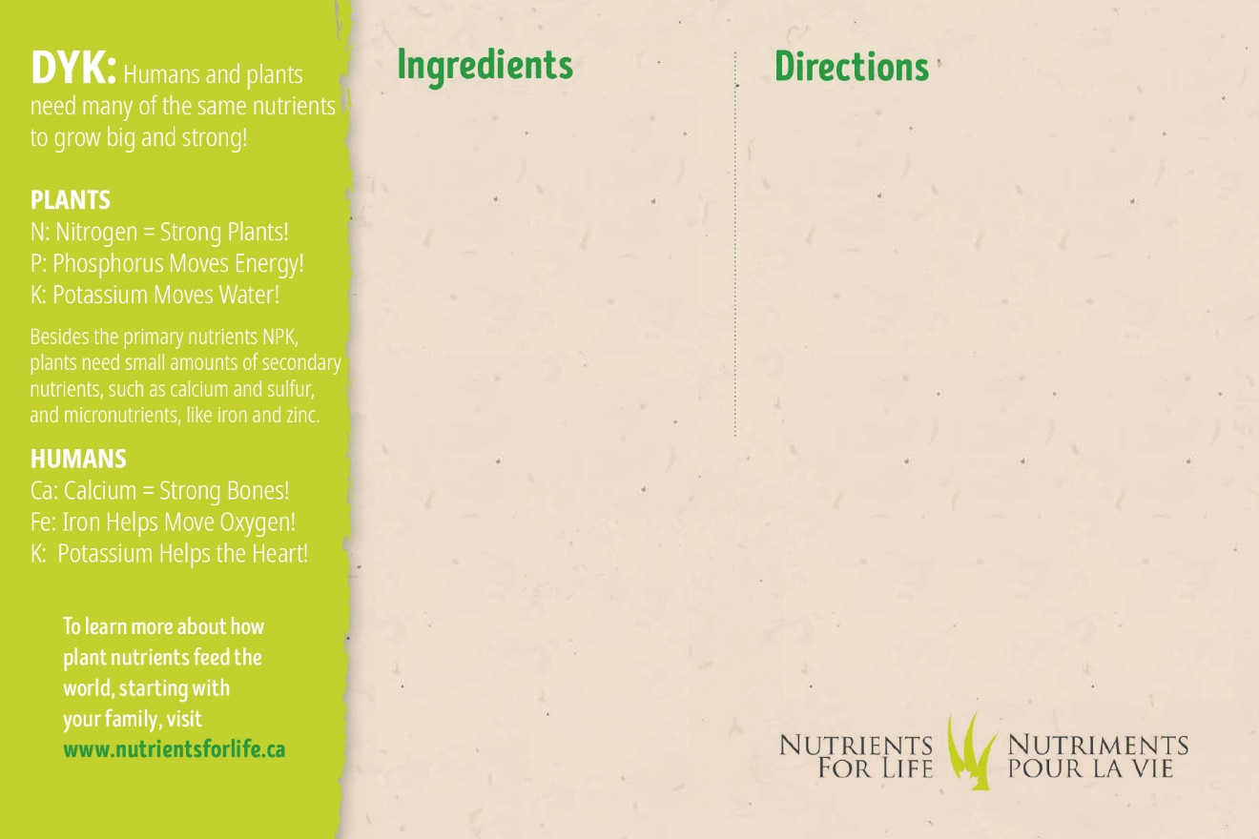

|  |  |  |
| --- | --- | --- |
| * Click or tap here to enter ingredients. |  | * Click or tap here to enter directions. |